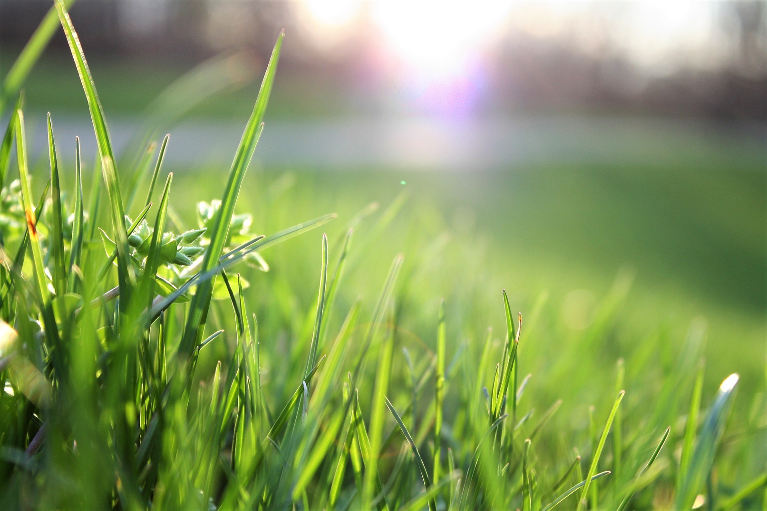





MSc. Data Science

Supervised By: **Dr. Yogesh Naik**

**WE HELP YOU WITH**

**TREE & SHRUB REMOVAL**

**PLANT & CROP PRUNING**

**WEED & PEST KNOWLEDGE**

**IRRIGATION TECHNIQUES**

**SMART AGRICULTURE**

**DEEP LEARNING FOR DETECTING PLANTS DISEASE THROUGH IMAGING**

A023 FARIA KHAN

A034 VINIT POOJARY

A038 AISHWARYA SHIRSAT

**16**

GROUP NO:

**AGROVISION**

**TABLE OF CONTENTS**

**Abstract** 1

**Introduction and Background** 2

Introduction: 2

Background: 2

**Problem Statement** 3

**Our Contribution to This Study** 3

**Literature Review** 4

**Hypotheses** 6

**Research Design and Methodology** 7

Research Objective: 7

Research Questions: 7

Research Design: 8

**1. Sampling Design** 8

**2. Observational Design** 8

**3. Operational Design** 8

**4. Statistical Design** 9

Research Methodology: 9

**Data Collection Strategy** 10

Dataset Overview: 10

About this Dataset: 10

Reasons for Choosing this Dataset: 10

**Toolset for Plant Disease Detection** 11

1. Algorithms & Models 11

• Why? 11

2. Toolsets 12

• Why? 12

3. Dataset 12

• Why? 12

**Data Analysis Approach** 13

**Project Timeline** 14

**Limitations and Future Scope** 15

Limitations 15

Future Scope 15

**Conclusion** 16

**Literature References** 17

**Abstract**

Plants play a crucial role in supplying food globally. Various environmental factors lead to plant diseases which results in significant production losses. The detection of plant diseases is a critical aspect of modern agriculture, significantly influencing crop yields, food security, and economic stability. Traditional methods for identifying plant diseases are often labour-intensive, time-consuming, and require expert knowledge, limiting their scalability. This research explores the application of deep learning techniques in automating plant disease detection through imaging, aiming to develop an efficient, accurate, and scalable solution. By leveraging **Convolutional Neural Networks (CNNs)** and **Transfer Learning**, the study proposes a robust framework for classifying plant diseases based on leaf imagery [1]. The integration of advanced deep learning models with cutting-edge imaging technologies promises to revolutionize agricultural practices, ensuring early detection of diseases, reducing losses, and promoting sustainable farming practices.

**Keywords:**

Plant Diseases, Precision Agriculture, Imagery Datasets, Image Processing, Machine Learning, Deep Learning, Transfer Learning, Image Classification, Object Detection, and Semantic Segmentation, Multi-Label Classification, Explainable AI (XAI)

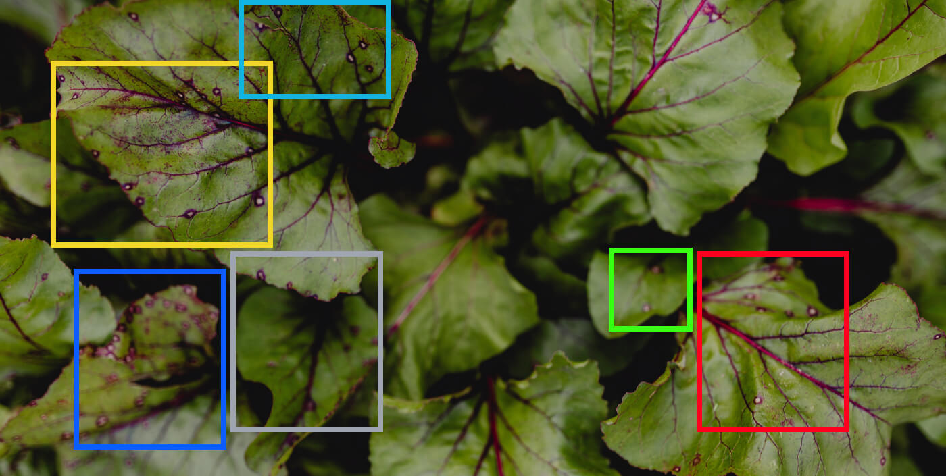

**Introduction and Background**

## Introduction:

***Agriculture remains the backbone of many economies, providing food security and livelihood for billions worldwide.*** However, the sector faces significant challenges, with plant diseases being one of the most pressing issues. These diseases can lead to substantial reductions in crop yield, adversely affecting global food supply chains. Detecting plant diseases early is crucial to mitigating these losses and ensuring sustainable agricultural practices. Traditional methods of plant disease detection, such as manual inspection by experts, are time-intensive and often impractical for large-scale farming operations. Moreover, these methods are prone to human error and may not detect diseases at an early stage.

With advancements in technology, deep learning has emerged as a transformative approach in **image-based disease detection**. Deep learning models, particularly **convolutional neural networks (CNNs) [1]**, have demonstrated unparalleled performance in **image classification** tasks. These models can analyze complex patterns in plant leaf images to identify diseases with **remarkable accuracy**. This research aims to delve into the potential of deep learning for plant disease detection through imaging, exploring its applications, challenges, and future prospects.

## Background:

Historically, plant disease detection relied on *visual inspections* and *laboratory tests*. While effective, these methods were neither scalable nor efficient. The rise of **Machine Learning** provided an alternative, enabling the development of models that could classify plant diseases based on specific features. However, traditional machine learning methods often required extensive **feature engineering** and struggled to **generalize** across diverse datasets.

Deep learning has revolutionized this field by automating feature extraction and learning **complex patterns** directly from **raw data**. CNNs, in particular, have shown exceptional capabilities in analyzing high-dimensional data, making them ideal for image-based applications [1]. Recent studies have utilized CNN architectures such as **AlexNet [3], VGG, ResNet [2],** and **GoogleNet [3]** for plant disease detection, achieving high levels of accuracy. However, these models often face challenges related to overfitting, computational requirements, and dataset limitations. This research seeks to address these challenges, leveraging advancements in **transfer learning [1]** and **data augmentation** to create a robust and scalable solution for plant disease detection [2] [4].

**Problem Statement**

***The global agricultural sector faces significant challenges due to crop diseases, which can cause yield losses ranging from 20% to 40%, threatening food security and economic stability, especially for smallholder farmers.*** Traditional methods of plant disease detection rely heavily on expert inspection, which is time-consuming, expensive, and prone to human error, particularly in large-scale or remote farming environments. **Advances in** **Deep Learning offer a promising alternative**, yet the existing approaches face limitations such as dependence on controlled datasets, lack of generalization to field conditions, and limited capability in early disease detection and multi-disease classification. Despite the availability of large datasets like **PlantVillage**, issues such as dataset bias, inadequate diversity, and challenges in adapting models to real-world conditions remain unresolved. Therefore, there is an urgent need to develop a robust, scalable, and interpretable deep learning model that can accurately detect and classify plant diseases under **diverse field conditions**, while addressing gaps in data quality, model generalization, and early-stage disease identification.

**Our Contribution to This Study**

This study addresses **key challenges** in plant disease detection, such as the lack of diverse, real-world datasets and limited focus on multi-disease classification. We aim to leverage advanced deep learning models like ResNet and InceptionV3 while incorporating multi-modal imaging techniques (RGB, hyperspectral, and thermal) to enhance detection accuracy and generalization under real-field conditions. Additionally, we focus on creating **lightweight models** optimized for mobile and real-time applications, making the technology accessible to farmers in rural and resource-limited areas.

To overcome the controlled nature of existing datasets like PlantVillage, we incorporate real-field data and apply **data augmentation** to simulate diverse environmental conditions.

One of the most significant gaps in plant disease detection research is the **lack of explainability**. We bridge this gap by using **XAI techniques** such as saliency maps and Grad-CAM to provide clear visual explanations for predictions. This not only improves trust and usability but also ***empowers farmers to understand the disease diagnosis process better***.

We aim to develop mobile-friendly, real-time diagnostic tools with features like disease severity prediction and actionable treatment recommendations, ensuring accessibility and **ease of use for Indian farmers.**

**Literature Review**

***Citation 1:*** *Li, L., Zhang, S., & Wang, B. (2021). Plant disease detection and classification by deep learning—a review. IEEE Access, 9, 56683-56698.*

Overview:  
This paper reviews the application of deep learning for plant disease detection, focusing on challenges like dataset size, transfer learning, and visualization techniques. The review highlights **convolutional neural networks** (**CNNs**) as the preferred models due to their ability to process and classify plant disease images with high accuracy. The authors also discuss common datasets, such as **PlantVillage**, and the use of **transfer learning** to address the lack of large datasets.

## Research Gaps:

## Dependence on large, labelled datasets, which are often unavailable for certain crops or diseases.

## Inadequate focus on early disease detection and real-time classification under field conditions.

## Limited use of visualization techniques to improve the interpretability of deep learning models

***Citation 2:*** *Shoaib, M., Shah, B., Ei-Sappagh, S., Ali, A., Ullah, A., Alenezi, F., ... & Ali, F. (2023). An advanced deep learning models-based plant disease detection: A review of recent research. Frontiers in Plant Science, 14, 1158933.*

Overview:  
This paper surveys the use of advanced deep learning architectures like **ResNet**, **DenseNet**, and **GANs** in plant disease detection. The authors provide a comprehensive analysis of recent progress in deep learning applications for **crop health monitoring**, focusing on the integration of advanced imaging modalities such as **RGB**, **hyperspectral**, and **thermal imaging**. While significant progress has been made, the authors highlight the need for scalable, user-friendly tools that can be deployed in real-world agricultural environments.

## Research Gaps:

## Limited generalization of models to field conditions with diverse environmental variables.

## Underutilization of advanced imaging modalities like hyperspectral and multispectral sensors.

## Absence of real-time systems or farmer-friendly tools for practical implementation.

## Lack of effective methods for combining disease severity estimation and identification.

***Citation 3:*** *Mohanty, S. P., Hughes, D. P., & Salathé, M. (2016). Using deep learning for image-based plant disease detection. Frontiers in plant science, 7, 1419.*

Overview:  
This seminal study demonstrates the feasibility of using deep learning for plant disease detection. Using the **PlantVillage** dataset, which contains over **54,000** **images** of **38 classes** (crop-disease pairs), the authors trained **CNNs** (**AlexNet** and **GoogLeNet**) to identify diseases in **14 crop species** with a reported accuracy of **99.35%**. The paper highlights the potential of deep learning for **smartphone-assisted** disease diagnosis on a global scale.

## Research Gaps:

## Limited exploration of real-world variability, including lighting, background, and environmental noise.

## No focus on detecting diseases in the early stages or handling simultaneous multi-disease identification.

## Lack of tools or pipelines for integrating the trained models into scalable, real-world applications like mobile apps.

***Citation 4:*** *Ahmad, A., Saraswat, D., & El Gamal, A. (2023). A survey on using deep learning techniques for plant disease diagnosis and recommendations for development of appropriate tools. Smart Agricultural Technology, 3, 100083.*

Overview:  
This paper surveys **70 studies** on deep learning for plant disease diagnosis and provides a roadmap for the development of robust tools to support **disease management in agriculture**. The authors emphasize key research areas such as dataset requirements, imaging sensors, deep learning models, and generalization. They highlight the limitations of current datasets, particularly their **imbalance** and **lack of field realism**. The paper concludes with recommendations for improving dataset quality, leveraging **advanced sensors**, and addressing research gaps through **multidisciplinary collaboration**.

## Research Gaps:

* Limited research on combining imaging technologies (e.g., RGB, hyperspectral, thermal) to improve model accuracy.
* Generalization of models to unseen data, different crops, and field images remains a challenge.
* Lack of studies focused on integrating deep learning with decision-making tools for disease management.
* Minimal work on comparing the performance of deep learning models with human expertise in disease detection.

**Hypotheses**

**Deep learning models incorporating multi-label classification can accurately identify multiple diseases affecting a single plant. [3]**

* **Null Hypothesis (H₀):** Deep learning models with multi-label classification do not significantly improve the accuracy of identifying multiple diseases affecting a single plant.
* **Alternate Hypothesis (H₁):** Deep learning models with multi-label classification significantly improve the accuracy of identifying multiple diseases affecting a single plant.

**Incorporating explainable AI techniques such as saliency maps or heatmaps will enhance trust and usability of plant disease detection tools among non-expert users like farmers.** (None of the four papers explicitly discuss incorporating explainable AI (XAI) techniques. ***Our study would fill this research gap by introducing interpretability methods to improve adoption among non-experts.***)

* **Null Hypothesis (H₀):** Explainable AI techniques such as saliency maps or heatmaps do not enhance trust and usability of plant disease detection tools among non-expert users.
* **Alternate Hypothesis (H₁):** Explainable AI techniques such as saliency maps or heatmaps enhance trust and usability of plant disease detection tools among non-expert users.

**Real-time diagnostic tools will reduce the time and resources required for disease identification compared to traditional manual inspection methods. [2]**

* **Null Hypothesis (H₀):** Real-time diagnostic tools do not significantly reduce the time and resources required for disease identification compared to traditional manual inspection.
* **Alternate Hypothesis (H₁):** Real-time diagnostic tools significantly reduce the time and resources required for disease identification compared to traditional manual inspection.

**Deep learning models trained on diverse datasets can match or surpass the accuracy of human experts in identifying plant diseases. [4]**

* **Null Hypothesis (H₀):** Deep learning models trained on diverse datasets do not match or surpass the accuracy of human experts in identifying plant diseases.
* **Alternate Hypothesis (H₁):** Deep learning models trained on diverse datasets match or surpass the accuracy of human experts in identifying plant diseases.

**Research Design and Methodology**

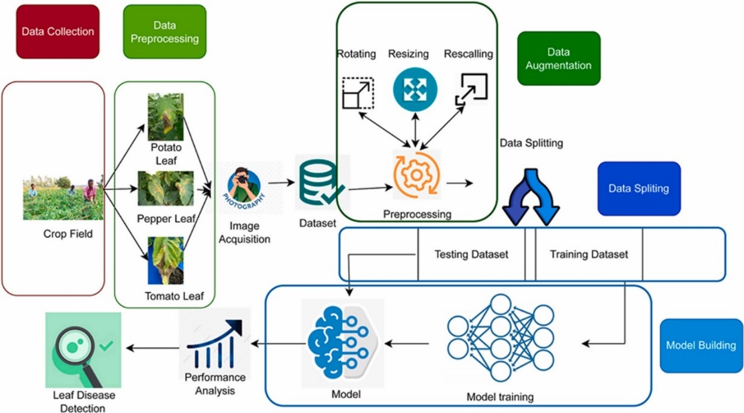

## An overview of the research process **[6]**

## Research Objective:

**The primary objective of this research is to develop a robust and scalable deep learning framework for accurate plant disease detection and classification,** addressing the limitations of existing models in generalization, dataset diversity, and real-world applicability. The study aims to integrate advanced imaging modalities such as RGB, hyperspectral, and thermal imaging to enhance early-stage disease detection and multi-disease identification. Furthermore, it seeks to improve the **interpretability** of deep learning models through **explainable AI** techniques and create a **user-friendly, real-time tool for practical use by farmers**.

## Research Questions:

1. How can diverse datasets, including real-field and augmented data, improve the generalization of deep learning models for plant disease detection?
2. What role do advanced imaging techniques (e.g., hyperspectral and thermal imaging) play in enhancing early disease detection and multi-disease classification?
3. How can explainable AI techniques improve the transparency and usability of plant disease detection tools for farmers?
4. Can a mobile-based real-time diagnostic tool effectively assist farmers in identifying and managing plant diseases?
5. How effective are CNN-based models in detecting and classifying plant diseases across diverse datasets?
6. What preprocessing techniques and data augmentation strategies optimize model performance?
7. Can lightweight deep learning models be deployed on low-powered devices for real-time disease detection?
8. How can model interpretability be improved to gain insights into disease classification decisions?

## Research Design:

### **1. Sampling Design**

**Objective:** To ensure the dataset represents diverse crops, diseases, and environmental conditions for robust model training and validation.

* **Population:** Images of **healthy** and **diseased** **plants** from various crops (e.g., apple, tomato, corn) and environmental conditions.
* **Sampling Method:** Stratified sampling to include a balance of controlled **lab** **images** (e.g., PlantVillage dataset) and **field-acquired images** under diverse conditions (real-world scenarios).
* **Sample Size:** A minimum of **10,000 images**, with a balanced distribution across crops, disease types, and severity levels to prevent class imbalance.
* **Inclusion Criteria:** Images with clear disease symptoms, varied backgrounds, and different imaging modalities (RGB, hyperspectral, thermal).

### **2. Observational Design**

**Objective:** To observe the performance of the model under varying conditions.

* **Type of Study:** **Experimental**, using controlled datasets (e.g., PlantVillage) and field datasets for comparison.
* **Key Variables:**
  + **Independent Variables:** Image modalities (RGB, hyperspectral, thermal), dataset diversity, augmentation techniques.
  + **Dependent Variables:** Model accuracy, F1 score, precision, recall, generalization to unseen field conditions.
* **Observation Protocol:** Split data into **training (80%), validation (10%),** and **testing (10%)** sets. Ensure the test set includes field images to evaluate real-world applicability.

### **3. Operational Design**

**Objective:** To define the model development process and evaluation criteria.

* **Model Development:**
  + Use pre-trained deep learning models (e.g., ResNet, EfficientNet) and fine-tune them on the dataset.
  + Employ transfer learning and data augmentation (rotation, scaling, synthetic data generation) for small samples.
  + Integrate multi-modal image inputs (RGB, hyperspectral, thermal) in a unified architecture.
* **Validation and Testing:**
  + Use **cross-validation** (e.g., 5-fold) to evaluate model consistency.
  + Test the model on unseen datasets to evaluate **generalizability**.
* **Deployment:** Develop a mobile-based application for real-time disease detection, integrated with explainable AI features like heatmaps.

### **4. Statistical Design**

**Objective:** To analyze and validate model performance using statistical methods.

* **Evaluation Metrics:**
  + Accuracy, precision, recall, F1 score, and area under the ROC curve (AUC-ROC).
  + Confusion matrix to analyze true positives, false positives, false negatives, and true negatives.
* **Statistical Tests:** Perform paired t-tests or ANOVA to compare the performance of different imaging modalities and model architectures.

## Research Methodology:

**Data Collection Strategy**

## Dataset Overview:

* + **Source**: Kaggle ([Dataset Link](https://www.kaggle.com/code/vipoooool/plant-diseases-classification-using-alexnet/input))
  + Contains labelled images of healthy and diseased plants across multiple species.

## About this Dataset:

**This dataset is recreated using offline augmentation from the original dataset. The original dataset can be found on**[**this**](https://github.com/spMohanty/PlantVillage-Dataset)**GitHub repo. This dataset consists of about 87K RGB images of healthy and diseased crop leaves which is categorized into 38 different classes. The total dataset is divided into 80/20 ratio of training and validation set preserving the directory structure. A new directory containing 33 test images is created later for prediction purpose.**

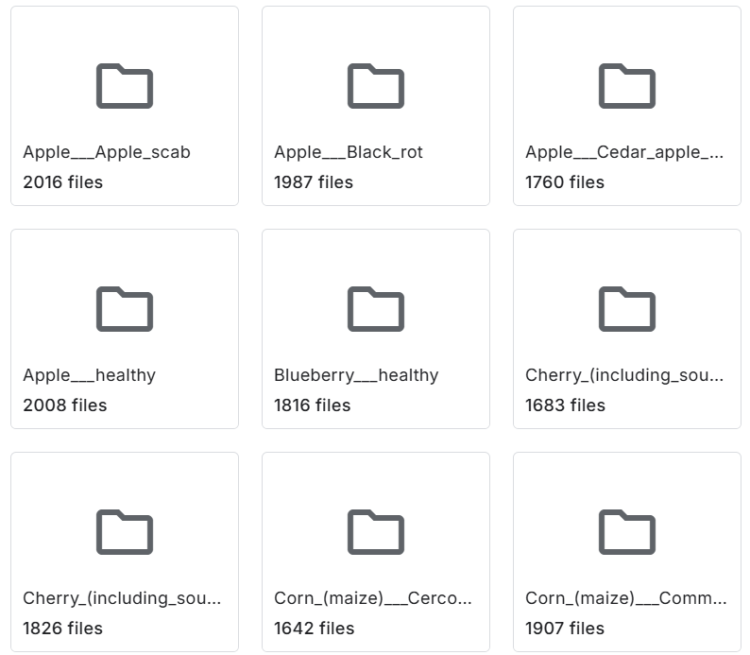

## Reasons for Choosing this Dataset:

1. Comprehensive Coverage:

The dataset includes images of multiple plant species with a wide variety of diseases, making it ideal for training a robust deep learning model.

1. Labelled and Organized:

Each image is pre-labelled and categorized by plant species and disease type, saving time on manual annotation.

1. High-Quality Images:

The dataset contains high-resolution images, ensuring better feature extraction for disease detection.

1. Benchmark Dataset:

Widely used in research, enabling easy comparison of results with existing methods and ensuring credibility.

1. Accessible and Free:

Available for public use on Kaggle, with no restrictions on usage for academic and research purposes.

**Toolset for Plant Disease Detection**

## 1. Algorithms & Models

* **Convolutional Neural Networks (CNNs):** CNNs are highly effective for image-based disease detection due to their ability to extract hierarchical features from plant images.
* **AlexNet & GoogleNet:** These architectures provide deep feature extraction capabilities, improving classification accuracy.
* **ResNet, InceptionV3, VGG (Transfer Learning):** Pre-trained models help leverage large-scale image features, reducing training time while improving performance.
* **Multi-Label Classification Models:** Used for cases where a plant may be affected by multiple diseases.
* **Explainable AI (XAI) Techniques:** Enhancing interpretability and usability for non-experts like farmers.
* Why?  
  CNN-based architectures have shown state-of-the-art performance in image classification tasks, making them ideal for plant disease detection. Transfer learning models help overcome the limitations of small datasets by utilizing pre-trained weights. XAI techniques allow us to understand how these models are operating.

*Apply XAI for Explanation*

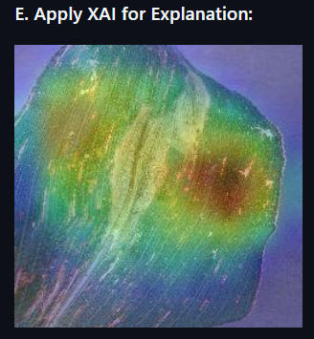

-But, while we were looking at the data, we saw something interesting. For most of the images we tested, our model seemed to zoom in on the right parts – the important areas of the pictures. This matching between where the program was looking and the correct parts of the pictures showed that our program was doing a good job at understanding and finding the important things. **[7]**

## 2. Toolsets

* **Python Programming Language:** Flexible and widely used in deep learning research.
* **TensorFlow & PyTorch:** Frameworks for building, training, and fine-tuning deep learning models.
* **Matplotlib & Seaborn:** For visualizing results and model performance.
* **Power BI / Tableau:** For dashboard-based visualization of results.
* Why?  
  These tools offer extensive libraries, GPU acceleration, and compatibility with cloud platforms for real-time applications.

## 3. Dataset

* **Dataset:** **PlantVillage (Kaggle)**
  + Contains of about **87k RGB images** of healthy and diseased plants.
  + Covers **38 plant-disease combinations** across multiple species.
  + Supports deep learning training with diverse, high-quality images.
* Why?  
  **PlantVillage** is one of the most comprehensive open-source datasets, widely used in plant disease research. Its diversity enhances model generalization and real-world applicability. Surveys ensure the tool aligns with end-user needs.

**Data Analysis Approach**

1. **Image Acquisition:** Collecting images of plants with visible symptoms of diseases using cameras or datasets.
2. **Image Pre-processing:** Preparing images for analysis by resizing to a standard dimension and normalizing pixel values.
3. **Data Augmentation:** Increasing the size and diversity of the dataset by applying transformations like rotations, flips, and brightness adjustments to existing images.
4. **Feature Extraction and Feature Selection:** Identifying and selecting key features (like leaf patterns or discoloration) that are relevant for disease detection.
5. **Model Selection:** Choosing a suitable deep learning architecture, such as Convolutional Neural Networks (CNNs) or pre-existing models like AlexNet and GoogleNet, for the classification task.
6. **Transfer Learning:** Leveraging pre-trained models to apply learned features from large datasets for plant disease detection, reducing the need for extensive training from scratch.
7. **Model Training:** Training the model by optimizing parameters like weights and biases using a curated dataset.
8. **Hyperparameter Tuning:** Fine-tuning model hyperparameters like learning rate and batch size to improve performance and reduce errors.
9. **Evaluation Metrics:** Measuring the model’s performance using metrics like accuracy (overall correctness), precision (true positives vs. false positives), recall (true positives vs. false negatives), and F1-Score (harmonic mean of precision and recall).
10. **Statistical Analysis:** Analyzing the results statistically to determine the significance of the model's performance improvements.
11. **Explainability & Interpretability (XAI):** Use saliency maps, Grad-CAM, and SHAP values to highlight affected plant regions. Assess whether explainable AI techniques improve usability and trust among farmers.
12. **Model Deployment:** Deploying the trained model in a real-time system, such as mobile apps or web-based tools, for practical use.
13. **Image Classification & Disease Detection:** Using the deployed model to classify input images and detect specific plant diseases, providing actionable insights to users.

**Project Timeline**

**Limitations and Future Scope**

## Limitations

* Dataset Limitations: The **PlantVillage dataset** consists mostly of lab-captured images with uniform backgrounds, which may not generalize well to real-world farm conditions (e.g., varying lighting, occlusion, and weather effects). Limited representation of **early-stage infections**, making early disease detection challenging.
* Computational Complexity: Training **high-performance deep learning models (ResNet, Inception, etc.)** requires significant computing power, limiting deployment on **low-resource mobile devices**. Real-time analysis might experience delays due to **high inference times** on complex architectures.
* Multi-Label Classification: While the study explores **multi-label classification**, current datasets lack large-scale images of plants with **multiple diseases**, leading to **limited model generalization** in real-world scenarios.

## Future Scope

* Real-World Dataset: Expanding the dataset by collecting **real-world images** from different **climates, geographies, and farm conditions** will improve model robustness. Including **multi-disease images** to enhance model generalization.
* Better Explainability: Enhancing **XAI techniques** to provide **localized disease explanations** in a farmer-friendly manner. Developing **voice-based or text-based AI assistants** in regional languages to improve usability.
* Automated Treatment Recommendations: Extending the model to suggest remedial actions, such as recommending fertilizers, pesticides, or crop rotation strategies based on detected diseases.

**Conclusion**

Agriculture is the backbone of India, supporting millions of farmers and contributing significantly to the economy. This study aims to revolutionize how plant diseases are detected by using advanced deep learning and explainable AI techniques. This technology makes it easier and more accurate to check the health of plants.

By using powerful neural networks and well-organized data, farmers can quickly identify problems and take actions. This not only helps them prevent crop losses but also supports more sustainable farming methods.

By addressing current challenges like the limited availability of real-world datasets, complex models, and the need for user-friendly tools, this research takes a step closer to empowering farmers with cutting-edge technology. With a focus on real-time, mobile-friendly solutions and practical features like disease severity prediction and treatment recommendations, this work envisions a future where Indian farmers can make quick, informed decisions to protect their crops and improve productivity.

In short, these technologies mark an important step forward for modern agriculture, helping to ensure a healthier and more efficient food production system.

**Literature References**

## Research Paper Citations (APA Format):

**[1]** Li, L., Zhang, S., & Wang, B. (2021). Plant disease detection and classification by deep learning—a review. IEEE Access, 9, 56683-56698.

**[2]** Shoaib, M., Shah, B., Ei-Sappagh, S., Ali, A., Ullah, A., Alenezi, F., ... & Ali, F. (2023). An advanced deep learning models-based plant disease detection: A review of recent research. Frontiers in Plant Science, 14, 1158933.

**[3]** Mohanty, S. P., Hughes, D. P., & Salathé, M. (2016). Using deep learning for image-based plant disease detection. Frontiers in plant science, 7, 1419.

**[4]** Ahmad, A., Saraswat, D., & El Gamal, A. (2023). A survey on using deep learning techniques for plant disease diagnosis and recommendations for development of appropriate tools. Smart Agricultural Technology, 3, 100083.

## Articles and Journals:

**[5]** <https://www.nature.com/articles/s41598-023-34549-2>

**[6]** <https://www.sciencedirect.com/science/article/pii/S2666154323002715>

## GitHub Links:

**[7]** <https://github.com/SalehAhmedShafin/XAI-and-Deep-Neural-Networks-for-Crop-Disease-Detection-and-Interpretability>

**[8]** <https://github.com/MarkoArsenovic/DeepLearning_PlantDiseases/tree/master>

**[9]** <https://github.com/Shubham-Jain-09/Crop-Disease-Detection/tree/master>